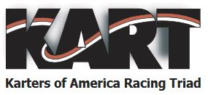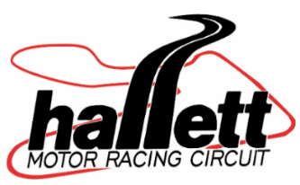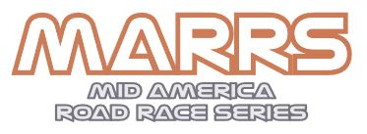

**Welcome, KART MARRS to**

**Hallett Motor Racing Circuitfor your**

**season opening event onApril 15-16, 2023!**

**Friday Test & Tuneparticipants Gates open**: Thursday night 5-10pm, then open Friday 6am.

[Click here to register online or register at check-in on 1st floor of tower](http://hallettracing.configio.com/pd/5578/?code=SXgFzHOFin).

**Sat/Sun participants Gates open**: Fri/Sat 6am-10pm, Sunday 6am-5pm.

**Finish Line Café** (by Sarah’s Dynasty Catering): breakfast and lunch all three days 7am –4pm. Use your cellphone camera on this QR code for the Finish Line Café menu.

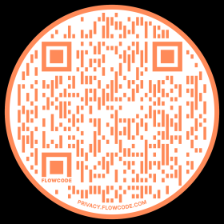

**Sunoco fuel**: available at facility just north of the HMRC Tower: 93 and 100 unleaded racing fuel

110 leaded racing fuel available with credit card pay at pump.(NOTE: KART OFFICIALS MAY CLOSE ACCESS TO FUELS TESTED AS ILLEGAL FOR KART RACERS, BUT IF NEEDED FOR OTHER USES SEE TOWER)

**Raceports/garages/RVspots:**HMRC has 28 covered raceports and 14 RVspots available to reserve.… allcovered raceports are booked up,but we still have RV spots available. Call Karen at 918-356-4814 or email[hallettracing2@cimtel.net](mailto:hallettracing2@cimtel.net).Other open-area paddock spots with electric hookup also available as first come, first served.

**Electric usage**: If you choose to plug into Hallett’s electric, purchase your electric stickers on 1st Floor for

20, 30, 50amp hookups found throughout the paddock. The growing population of RVs can cause brownouts and even blackouts, so try to limit over usage; bring a generator just in case!

**Air**: At small garage west of tower.

**Deliveries:**  UPS and FedX do not deliver to the track Sat/Sun.

**Hallett Souvenir Store**:  Gifts and Hallett apparel on the ground floor of the Tower (hoodies, shirts, hats, decals,coffee mugs, track maps, sunscreen, bug spray, jewelry, etc).

**Hallett Foto Shoppe:**Order ALL yourfull resolution photos from our track photographer on1stfloor of the Towerfor$50. TIP: Purchase early so he will be watching for you on track!

**Need a bed?** Call HMRC partnerVictorian Inn in Cleveland @ 918-358-3531 and ask for the special Hallett rate.

**Looking forward to a great event with GREAT people!**

Hallett Motor Racing Circuit (HMRC)

59901 E. 5500 Rd

Jennings, OK 74038

918-356-4814

[**www.hallettracing.net**](http://www.hallettracing.net)